WATERLOO MEDICAL CENTRE

PATIENT NEWSLETTER
SUMMER 2025
Are you a parent with a young child?

Healthier Together, in conjunction with the Royal College of Paediatrics and Child Health have a website with extremely useful information if you are concerned about the health of your child or just want general health information

Please visit the website at Home :: Healthier Together (what0-18.nhs.uk)
https://www.what0-18.nhs.uk

Please note, when you first enter the link, it will ask you for an area, please click other

Unattended Appointments

As we all know, it is extremely difficult to get appointments at any Surgery and we always strive to accommodate our patients as much as we are able to, however, it can be very frustrating when patients do not attend their pre-booked appointments with the GP or Nurse, thus preventing other patients from being seen.

In the months from 1st January to 30th June this year, 837 appointments were not attended

Please ensure you cancel any appointment you are unable to attend in good time to allow others to be seen hence not wasting the clinicians time.

We do have a Practice policy on DNA’s (did not attend), whereby after three consecutive DNA’s, a warning letter will be sent and any subsequent failures to attend thereafter may result in removal from our Practice List
Friends and Family Test

Thank you to everyone who has completed a Friends and Family feedback form. These help us to improve our services so your feedback, whether positive or negative is very welcome.
Forms can be found in the waiting room or ask one of the Receptionist, we also send SMS messages after your appointment, and would be grateful if you could complete these.

Ashton Social Prescribing
Social Prescribers help people to make new connections within the community and can signpost people to local groups, activities etc.
If you are aged 18+ and wish to improve your health and wellbeing, please see one of our receptionist for further details
- Become Active
- Socialise
- Find interests
- Get help
- Get involved

SUMMER’S HERE

Remember, the sun in this Country can burn you just as much as it can abroad – Please ensure you look after your skin by ensuring you use protection lotions.
A note to remember about protection lotions, some only last for a short period of time once opened and you will lose effective protection. Please check on the back of you sun lotion and there should be a guide to how long you can keep your lotion once it has been opened.

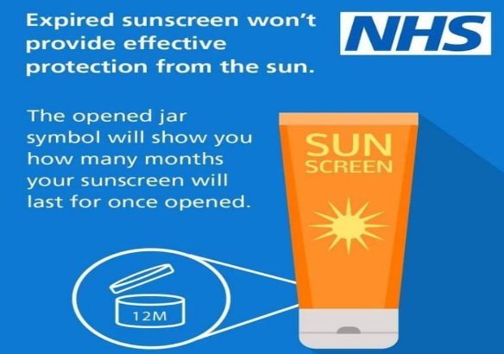

Are you ready for Summer !!

With school holidays on the horizon and looking for something to keep you all occupied, visit these websites :-

Tameside - What's On (intameside.co.uk) https://www.intameside.co.uk/whats-on

https://www.tripadvisor.co.uk/Attractions
THE 10 BEST Things to Do in Tameside with Kids (Updated 2024) (tripadvisor.co.uk)

