WATERLOO MEDICAL CENTRE
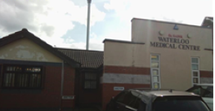
PATIENT NEWSLETTER
JUNE 2024
SUMMER’S HERE (somewhere !)

Remember, the sun in this Country can burn you just as much as it can abroad – Please ensure you look after your skin by ensuring you use protection lotions.

A note to remember about protection lotions, some only last for a short period of time once opened and you will lose effective protection. Please check on the back of you sun lotion and there should be a guide to how long you can keep your lotion once it has been opened.

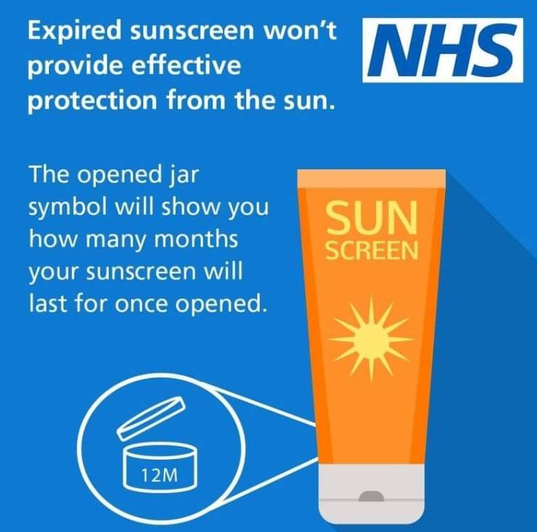

Unattended Appointments

As we all know, it is extremely difficult to get appointments at any Surgery and we always strive to accommodate our patients as much as we are able to, however, it can be very frustrating when patients do not attend their pre-booked appointments with the GP or Nurse, thus preventing other patients from being seen.

In the months from 1st January to 31st May this year, 747 appointments were not attended

Please ensure you cancel any appointment you are unable to attend in good time to allow others to be seen hence not wasting the clinicians time.

We do have a Practice policy on DNA’s (did not attend), whereby after three consecutive DNA’s, a warning letter will be sent and any subsequent failures to attend thereafter may result in removal from our Practice List
PPG GROUP

We are trying to recruit more members to our PPG (Patient Participation Group) where we currently meet every six months, but are hoping to increase this to at least three times a year.

A Patient Participation Group (PPG) is a group of patients, carers and GP practice staff who meet to discuss practice issues and patient experience to help improve the service.

If you are interested in joining our Group, please let the Receptionist know.

Ashton Social Prescribing
Social Prescribers help people to make new connections within the community and can signpost people to local groups, activities etc.
If you are aged 18+ and wish to improve your health and wellbeing, please see one of our receptionist for further details
- Become Active
- Socialise
- Find interests
- Get help
- Get involved

Prescriptions

Repeat prescriptions - cannot be taken over the telephone for safety reasons – please download the NHS App.

Hospital Prescriptions – If you are given a prescription at the Hospital, please take it to the Hospital Pharmacy as we are not responsible for re-issuing these – even if there is a long wait ! Sorry

Private Prescriptions – We are not responsible for issuing prescriptions for any drugs recommended by any private clinic.

Accessing further Care

All Surgeries in Ashton work alongside each other as part of the Primary Care network (PCN) helping to serve our Ashton population.

There may be times when we may offer you an appointment at the Ashton Hubs, which are based at Stamford House on Mossley Road and Ashton Primary Care Centre on Old Street. These appointments are for evenings or weekends and may be more convenient for our working population.

These hubs are serviced by GP’s, Practice Nurses, HCA’s, Pharmacists etc who all work locally within the Ashton Practices.

Please ask the receptionist for further details

