WATERLOO MEDICAL CENTRE

PATIENT NEWSLETTER
AUGUST 2024
Practice Survey
Throughout August, we are conducting our own Surgery Survey, this is in addition to the friends and Family Test that we are contracted to complete each month.

We always value the opinion of our patients and would be grateful if you would assist us in completing the Survey. These can be handed into reception or posted in our suggestion/complaints box in the waiting room.

The recent National Survey showed a huge improvement from recent years, the Practice was also above average when comparing with other Practices

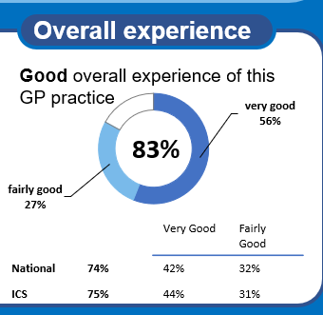

Are you ready for Summer !!

With school holidays on the horizon and looking for something to keep you all occupied, visit these websites :-

Tameside - What's On (intameside.co.uk) ht tps://www.intameside.co.uk/whats-on

https://www.tripadvisor.co.uk/Attractions
THE 10 BEST Things to Do in Tameside with Kids (Updated 2024) (tripadvisor.co.uk)

CARE NAVIGATION/SIGNPOSTING

When you contact the Practice to book an appointment with the GP, there may be a more appropriate clinician or service that can best deal with your request. Reception staff have on-going training in care navigation in order to signpost to the most appropriate clinician or service, by enabling this to be done, we can ensure the GP is free to see patients who need them the most.

Signposting helps patient to receive the right care, from the right professional at the right time.

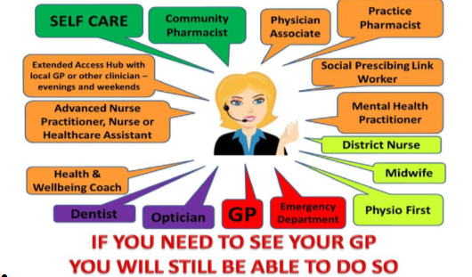

Anyone requiring advice or treatment for urgent, but not life-threatening, medical issues should continue to seek NHS support via NHS 111 online or by telephone. NHS 111 has full knowledge of, and access, to local services and can arrange the right care depending on a patient’s needs.
People requiring urgent mental health support can find their local 24/7 NHS urgent mental health helpline and other support options at Where to get urgent help for mental health - NHS (www.nhs.uk)

Community Pharmacies also provide a wide range of services for minor illnesses.

Evening and Saturday appointments are available across Tameside and can be booked via our receptionist.

Remember, Ambulance and A&E services remain available for those with life threatening conditions requiring emergency care

